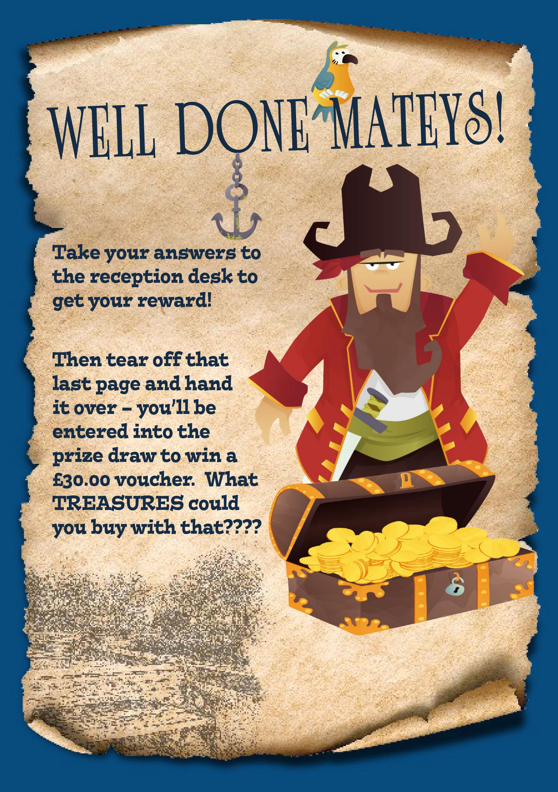

Well done Braydon
You are the first winner of the prize draw for the Great Gainsborough Treasure Hunt!
Here is your £30 spending card to go and buy your own special treasure.
Have fun me hearty!
From
Captain Will Smith and The Townscape Heritage Initiative
West Lindsey District Council

